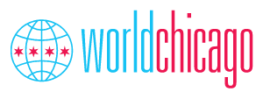
Messaging report from South Communication Consultants
Yasmeen Scott, Catherine Hale, Amudalat Kasumu

Table of Contents:
- Background
- Communication Audit
- Media Relevancy
- Target Audiences and Messaging Strategies
- Goals and Objectives
- Suggested Tactics
- Conclusion
- References

Background

WorldChicago has made their cause known which is Citizen Diplomacy. It is who they are and what they do. The problem is the tangible execution of how their organization functions is a bit murky. We’ve conducted a communication audit, a brand analysis, and identified goals and objectives for the organization and we are recommending our messaging strategies. The mission of WorldChicago is incredibly important, and our goal is to make sure that the organization’s communications are doing everything they can to further the goal of citizen diplomacy. The world is a changed place in the wake of 2020. This is a perfect opportunity for WorldChicago to emphasize the individual responsibility that citizens can have to change the world.
Communication Audit
On the WorldChicago website, they post about their upcoming events on citizen diplomacy, leadership, and testimonials from mentors and hosts. Each individual tab under their ‘Our Work’ page and their ‘What we do’ gives more background about the programs they offer. They do a good job explaining what citizen diplomacy is, what professional exchanges are and use testimonials to prove the value of participating in the programs. Their actual press page has some recent stories, but some links are no longer usable from WBEZ Worldview & Magazine for Chicago Women. The website includes a great deal of information and details about their work, but the organization of this information could be modified to make the communication clearer.
Their posts on Instagram are consistently about events and ideas happening in the Chicagoland area, international relations and local relations connecting people to one another. They use testimonials from those who have either participated in the program or are interning to give a more real-life perspective for those thinking about participating in the future. They get around 15-20 likes for the average post but up to 40-50 for other posts, but there is hardly any dialogue (including comments from followers) on the platform. Their goal is to get young professionals interested in exchange programs as well as donating to their Young Diplomats program. WorldChicago’s Instagram has a little over 1,200 followers on their page. The content that seems to get the most engagement is when they focus on people either in the organization sharing their knowledge and importance of exchange programs or those in the program or attending events that highlight top international business leaders.
A majority of the content on the WorldChicago Twitter account is focused on citizen diplomacy, local and international travel, cultural exchange, and exploring the Chicagoland area. The tweets, replies, retweets, likes and media are about relevant events occurring in the Chicagoland region, global and regional relations, as well as associating individuals to each other through one of the various WorldChicago’s programs available. They also share posts that discuss news items that are relevant to the organization from sources like the US State Department and Global Ties US.
The organization posts on Facebook consistently. During January 2021, WorldChicago posted 21 times throughout the month, and their interactions on each post fell somewhere between 3 and 23, averaging around 10 likes/interactions total per post. The content they post tend to be focused on organizational updates (new staff, upcoming events, etc) or acknowledging significant and relevant events in America like MLK day or the appointment of a new Secretary of State. The voice of their posts is consistent. They express enthusiasm for their content and for their purpose of unity.
One of the benefits of the Facebook platform is that it allows for pages to advertise their events very clearly. The feature that lets you respond to events by saying you’re “interested” is incredibly valuable. For the next month, WorldChicago has three events listed. While most of their posts have very low levels of engagement, their event announcements seem to have more of a response from their followers. Part of this could be due to the fact that some of the events have been posted on the page multiple times, presumably collecting a few new RSVPs each time it was put on the Facebook feed. This strategy seems to be effective for them.
The key theme in all of the communication efforts on WorldChicago’s Twitter account is advancing citizen diplomacy and worldwide understanding of U.S international relations as well as other supporting global guests every year. They include testimonies from the individuals who have either partaken in the program or are interning to give an all the more genuine viewpoint for those considering partaking later on. WorldChicago gets a low measure of engagement (looking at likes, retweets, mentions and replies) for each post, an average of 1 to 15 persons interacting. Taking a closer look at the tone of the coverage shows that it is very informative for their audience.
Since WorldChicago is a relatively small organization that doesn’t get mentioned in the media, we decided to review coverage of relevant topics to the organization in order to better understand how WorldChicago can remain up to date with the issues facing them. Our client mentioned that some issues facing them including the unrest that has been exhibited in the past few years in American politics; the COVID-19 pandemic and the insurrection at the Capitol on January 6th was specifically cited as communication issues to overcome. The events of the past year pose the idea that is so central to WorldChicago, which is continuing to make the United States and Chicago more specifically a safe space for everyone. In the past, citizen diplomacy has been interpreted through the lens of America as a beacon of successful democracy and entrepreneurship. That global perception of America has shifted in light of recent events, and so it is vital for us to examine what diplomacy looks like on a national level so we can understand how the client could now approach the purpose diplomacy serves on an interpersonal level.
A recent article from the Chicago Tribune goes into detail about world traveling during COVID. Having a U.S. passport used to give you freedom to travel more easily and would qualify you for exemption from needing a visa to go to many countries. It was seen as an ultimate privilege to have a U.S. passport. Now things are changing because the United States doesn’t have free or manageable healthcare during this time of crisis, and other countries want to limit our traveling abilities while they get the virus under better control. This article focused on a group of U.S. tourists who were trying to go to the Italian island of Sardinia and were denied entry. The United States is facing a crisis when it comes to international relations. As the failings of our government’s response to the pandemic become increasingly obvious, our relationship with other countries is becoming more and more strained. WorldChicago’s mission of citizen diplomacy is going to have to adjust when the world opens back up to travel in light of the new global perception of our country.
Another article from the Chicago Tribune pointed out that some people, as a new year’s resolution, don't just want to travel for pleasure anymore. Since the pandemic and Black Lives Matter protests of 2020, they want to travel with a cause both domestically and abroad. They are looking for mission driven trips since they are a way to self-identity and help with personal growth. People are also looking to go places around the world, they haven’t been before and make new connections. There is a new sense of urgency now with being unable to travel for about a year. Now people want to see as much of the world as possible when it is safe to do so. The tone of this article seemed hopeful for the future. This will be very important to WorldChicago once it is safe to travel and explore because they could see a surge of people be interested in their program in order to get experience working and build new networking connections, since they have been unable to for a long time.
President Biden gave his first foreign policy speech as president of the United States in February 2021. The central idea he put forward is that “America is back.” In the post-Trump era of American politics, diplomacy is once again going to be the central focus and purpose of American foreign policy. Biden said, “we must start with diplomacy rooted in America’s most cherished democratic values: defending freedom, championing opportunity, upholding universal rights, respecting the rule of law, and treating every person with dignity.” The emphasis placed on treating each person with dignity is exactly the point of citizen diplomacy. WorldChicago’s mission is to extend dignity to every individual through building personal relationships. The new trajectory that America’s foreign policy is taking is shifting to the same kind of diplomatic mission WorldChicago has.
There is a concern, though, among foreign policy experts that a return to pre-Trump era policy is not enough. The world is facing rising tides of fascism, authoritarianism, and an urgent climate crisis. These are the issues that we should all be concerned about as global citizens, but they are of great importance to an organization like WorldChicago. WorldChicago values acceptance, unity, and understanding. Having a sense of international awareness is an asset to the organization. The tone that media outlets are using to discuss policy is cautiously optimistic. There is hope in the future of foreign policy being more diplomatic, but a hesitance to declare Biden’s measures fully good in light of the fact that previous policy is not enough to meet the growing concerns the world is facing. This is something we are paying attention to when it comes to relevant topics and keywords over the past year in our analysis.
Looking at the data from Brandwatch (both 2020 and 2021), the topics that received the most attention were the “United States”, “cultural exchange that we share”, & “money is so devalued” all of which received negative attention from the social media users. Interestingly, the tone overall from users was mostly neutral. WorldChicago received the most attention across the social media platform hashtags which include the following: #publicdiplomacy, #diplomacy, #citizendiplomacy, #exchangesimpact, #marketing, & #exchange which stood out for WorldChicago to pay attention to in moving forward because they emphasize exactly what they are trying to accomplish with their organization on a daily basis.
In our media audit, we found that not enough people know about the benefits that WorldChicago’s Young Professional Group has to offer. The benefits of global exchange, networking, and leadership building are invaluable. If WorldChicago could attract more members in their YP group, it would further their cause. In regard to the corporate partners, WorldChicago needs to communicate who they are as an organization.

Target audience
We are planning to target young professionals in the Midwest between ages 18-35, men and women. According to our client brief from Morgan Lyn last month, this is a key demographic WorldChicago is trying to connect with that they have been having difficulty reaching. Our group believes that this market makes sense because these are the people most likely to travel for work and pleasure. They are just getting started in their field and are looking to network and gain experience. Younger millennials and Gen Z are growing in their collectivist attitudes, and they want to be active in their global ties. According to an article in the Chicago Tribune, the events of the past year- Black Lives Matter, the pandemic, climate change, etc.- has only increased the longing rising professionals have to make an impact for good. People are looking for experiences and jobs that are purpose driven, and WorldChicago is exactly that.
Our second target is corporate sponsors. As Morgan Lyn mentioned in our client brief, WorldChicago would really like to focus their energy on getting corporate partners to be more financially involved in the organization. Since they are a non-profit, they require donations to keep running. Lyn said there are several companies that they are partners with already in that those companies provide opportunities for their professional exchanges. The hope is that these existing partnerships can evolve to becoming sponsors in future endeavors with WorldChicago.
Based on the client brief, our group has come to the conclusion that young professionals and corporate partners are who we need to target. For the young professionals, our communication goals are centered around awareness. We want young people to be aware of WorldChicago as an organization and the benefit of network building that comes with involvement in the organization.
Storytelling is an effective way to capture the interest of both young professionals and corporate sponsors. WorldChicago does a good job of posting regularly and maintaining the voice of their organization in the output they have, but it could be beneficial to utilize narrative storytelling about people who are current exchange students or previous exchange students in their messaging. This would continue to engage the target audiences instead of just posting about events, organizational happenings and overall worldwide holidays which are important but not the biggest draw for retention. WorldChicago is good at keeping their public updated on their events, but it seems as though they struggle to maintain stakeholder interest based on their current engagement levels on their social platforms. People want to buy into a narrative when they support an organization. While Covid-19 makes face to face interactions off limits, virtual narratives are a way to share personal experience safely. Because of this, we want to focus our messaging on how participation with WorldChicago expands networks.

Goals
- To increase engagement of the resources WorldChicago has to offer to young professionals.
- To communicate the mission of WorldChicago more clearly to current and future corporate partners.

Objectives:
1.1 To increase young professionals’ engagement with WorldChicago posts on Twitter and Instagram by 20% by December 2022.
1.2 To increase Young Professionals following WorldChicago social media pages by 50% by the end of 2022.

2.1 To gain five new corporate sponsors by December 2022.
2.2 To educate existing strategic partners and foster long term corporate sponsorship about WorldChicago mission by December 2022.

Selected channels
Based on our findings through our communication audit, cited articles, goals and objectives, we are suggesting that WorldChicago focuses on integrating their messaging on the following channels:
Shared Media: Twitter, Facebook & Instagram
Owned Media: Website Video & Blog Posts

One of the things the client mentioned was that their alumni network was strong and supportive. We believe that the key messaging for WorldChicago is about expanding network building and globalization for our target audiences. Their website features accounts from alumni who have had wonderful experiences with the organization. We recommend that sharing some of those stories via social media to give stakeholders examples of citizen diplomacy that feel tangible and allows alumni to feel engaged in the organization even though they aren’t actively participating anymore. Human connection is driven by storytelling, and so is WorldChicago. They believe that the world is changed through interpersonal connection.

Suggested Tactics
TACTIC #1 - Social Media Fliers
These straightforward fliers can be shared through Twitter, Instagram, Facebook and the organization's site. All posts should be accompanied with the caption #OneHandShakeAtATime and #GetInvolved. The size of this sample flier can be modified and used across the social media platforms. Our findings from the Chicago Tribune article pointed out the ways young people are searching for opportunities to be better world citizens. We hope this will resonate with young professionals, as many people are turning to social media infographics as a way to inform them about ways, they can take action.
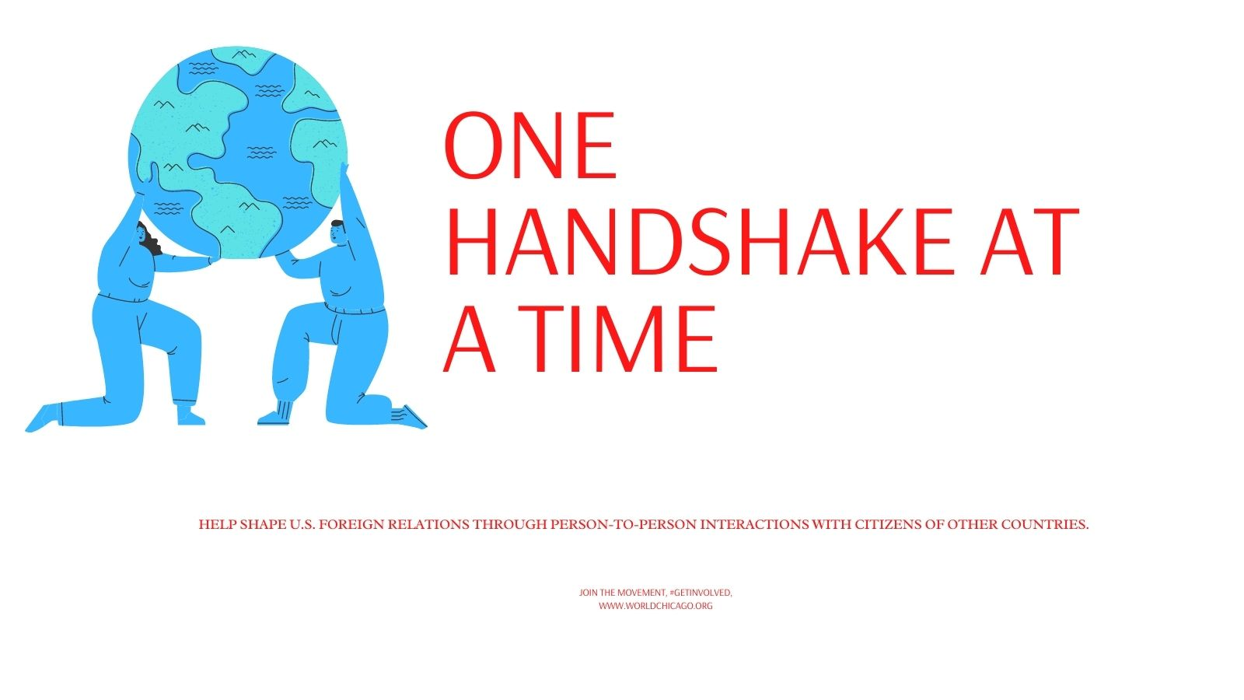

Copy- Help shape U.S. foreign relations through person-to-person interactions with citizens of other countries. Join the movement, #Getinvolved www.worldchicago.org

TACTIC #2 - Website Video
Another tactic we suggest is to create a video detailing the benefits of partnering with WorldChicago thus putting a name to the face of the organization. This will help benefit corporations who are looking for more information about the organization. The content of the video would be similar to the “What we do “page of the site and would be uploaded to the website as an additional resource for corporate sponsors to see when browsing the site.
In the current video on their website, there are still ideas that can be clarified for the average visitor that doesn’t know anything about the organization. The current video is 11 years old and would benefit from updating as the organization has grown and changed in that time. The director of the organization simply describes the function of the organization as hosting federal and government sponsored visitors from other countries. WorldChicago offers a bigger purpose that has yet to be uncovered. Our idea is that in order to build a better rapport with corporate partners, the partners should be more fully informed of the organization’s function and purpose.
The concept of citizen diplomacy is very well communicated on the website. WorldChicago makes it very clear that their mission is to create a more interconnected world, “One handshake at a time,” but the practical application of that statement is hard to find written out in one place.
In the video, we would like to suggest that someone from the organization describe all of the functions of the organization. It would be beneficial to hear a description of their exchange programs, their young professionals’ group, their hosting process, and everything else they do break down clearly and all in one place. The testimonial aspect of the video they currently have is good, but one thing that should be clarified is the role the participants who are speaking have played in the organization. This is listed for some of the speakers, but not all. Their shared experiences would be more impactful if they were giving more context to the role they played.
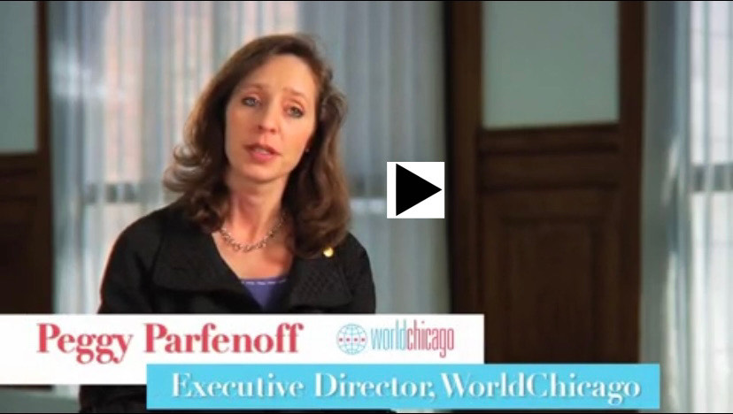

TACTIC #3 Twitter and Instagram Posts.
Scheduled tweets posted regularly that are clear and simple enough to pass the organization's core message to young professionals in the Midwest, especially those in the Chicagoland area. This image and copy could be used across both platforms.

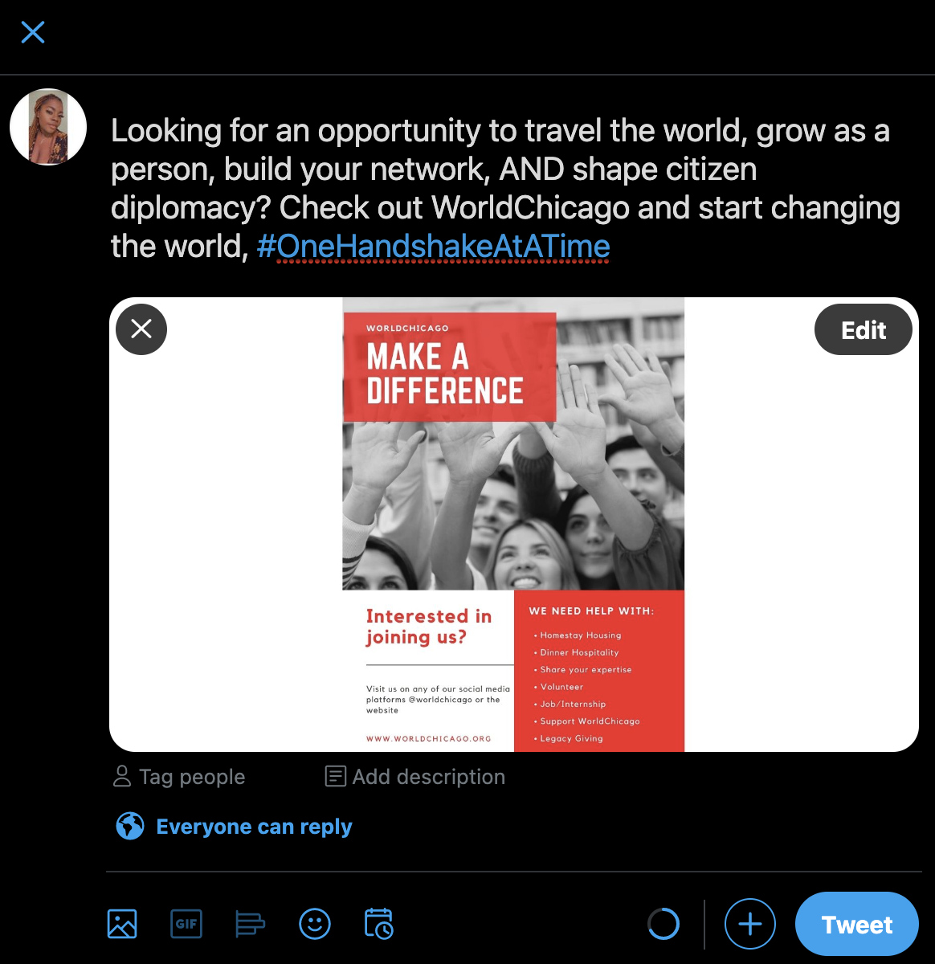

TACTIC #4 Blog Posts from Alumni
In order to get more young professionals to buy into the mission of WorldChicago, we suggest asking members of the alumni network to write blog posts about their experiences. This would be beneficial in maintaining relationships with alumni as well as creating the narrative structure that young people are looking for when they are searching for organizations to associate with. Additionally, this could appeal to corporate sponsors who are looking to understand how the program has successfully run in the past to create business connections and expand international networks.
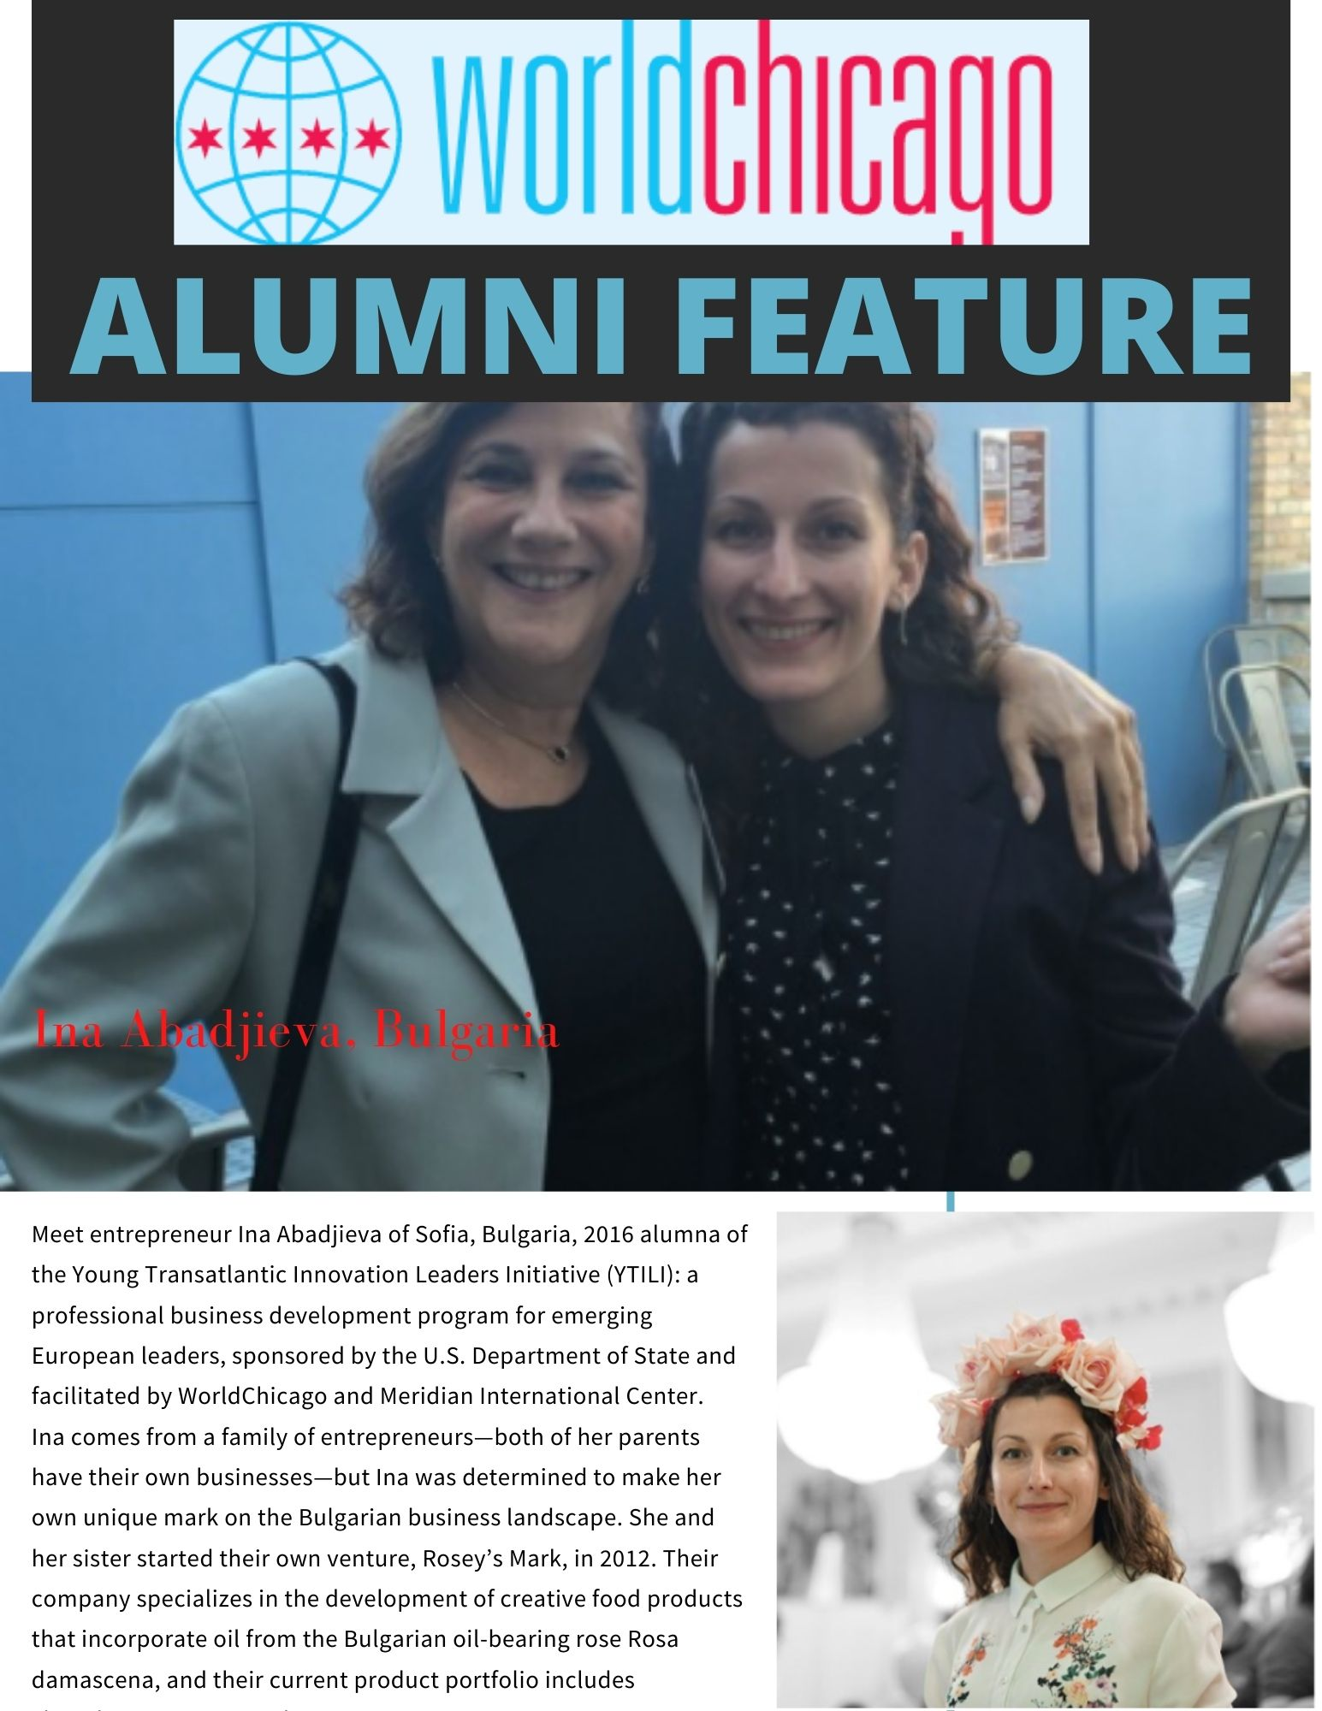

Conclusion
The main takeaways we want you to walk away with are that Citizen Diplomacy is crucial now more than ever, and that being involved with WorldChicago is an opportunity to expand one’s mind and network. Our hope is that by appealing to the desire of young professionals and to be better global citizens, we will attract more participants to WorldChicago’s exchanges and groups. Similarly, we hope that by clearly communicating the functions and benefits that WorldChicago has to offer through clear and defined messaging, it will draw support from existing and new corporate sponsors.

References
Diplomats, top EXPERTS' views on Biden's foreign policy speech. (2021, February 05). Retrieved March 16, 2021, from https://www.justsecurity.org/74547/diplomats-top-experts-reactions-to-biden-foreign-policy-speech/
Glusac, E. (2021, January 22). Traveling with a purpose: For some, it's a 2021 resolution. Retrieved March 16, 2021, from https://www.chicagotribune.com/travel/sns-nyt-traveling-with-a-purpose-20210122-4nl3ice3anaz3m7us5mce634dm-story.html
Lotts, D. (2021, January 30). Business or pleasure: The travelling habits of millennials. Retrieved March 16, 2021, from https://everydaypower.com/business-pleasure-travelling-habits-millennials/#:~:text=The%20same%20study%20found%20that,'%20(business%20%2B%20pleasure).
Remarks by President Biden on America's place in the world. (2021, February 05). Retrieved March 16, 2021, from https://www.whitehouse.gov/briefing-room/speeches-remarks/2021/02/04/remarks-by-president-biden-on-americas-place-in-the-world/
Specia, M. (2020, July 08). Travel restrictions on AMERICANS erode a sense of PASSPORT PRIVILEGE. Retrieved March 16, 2021, from https://www.chicagotribune.com/travel/sns-nyt-restrictions-erode-american-passport-privilege-20200708-kefigusjr5acblgjnzlnrglcqy-story.html
WorldChicago. (2009, June). Retrieved March 16, 2021, from https://twitter.com/WorldChicago
WorldChicago. (2010, May 20). Retrieved March 16, 2021, from https://www.facebook.com/worldchicagodiplomacy
WorldChicago. (2020). Retrieved March 16, 2021, from https://www.worldchicago.org/press
WorldChicago. (n.d.). Retrieved March 15, 2021, from https://www.instagram.com/worldchicago/

